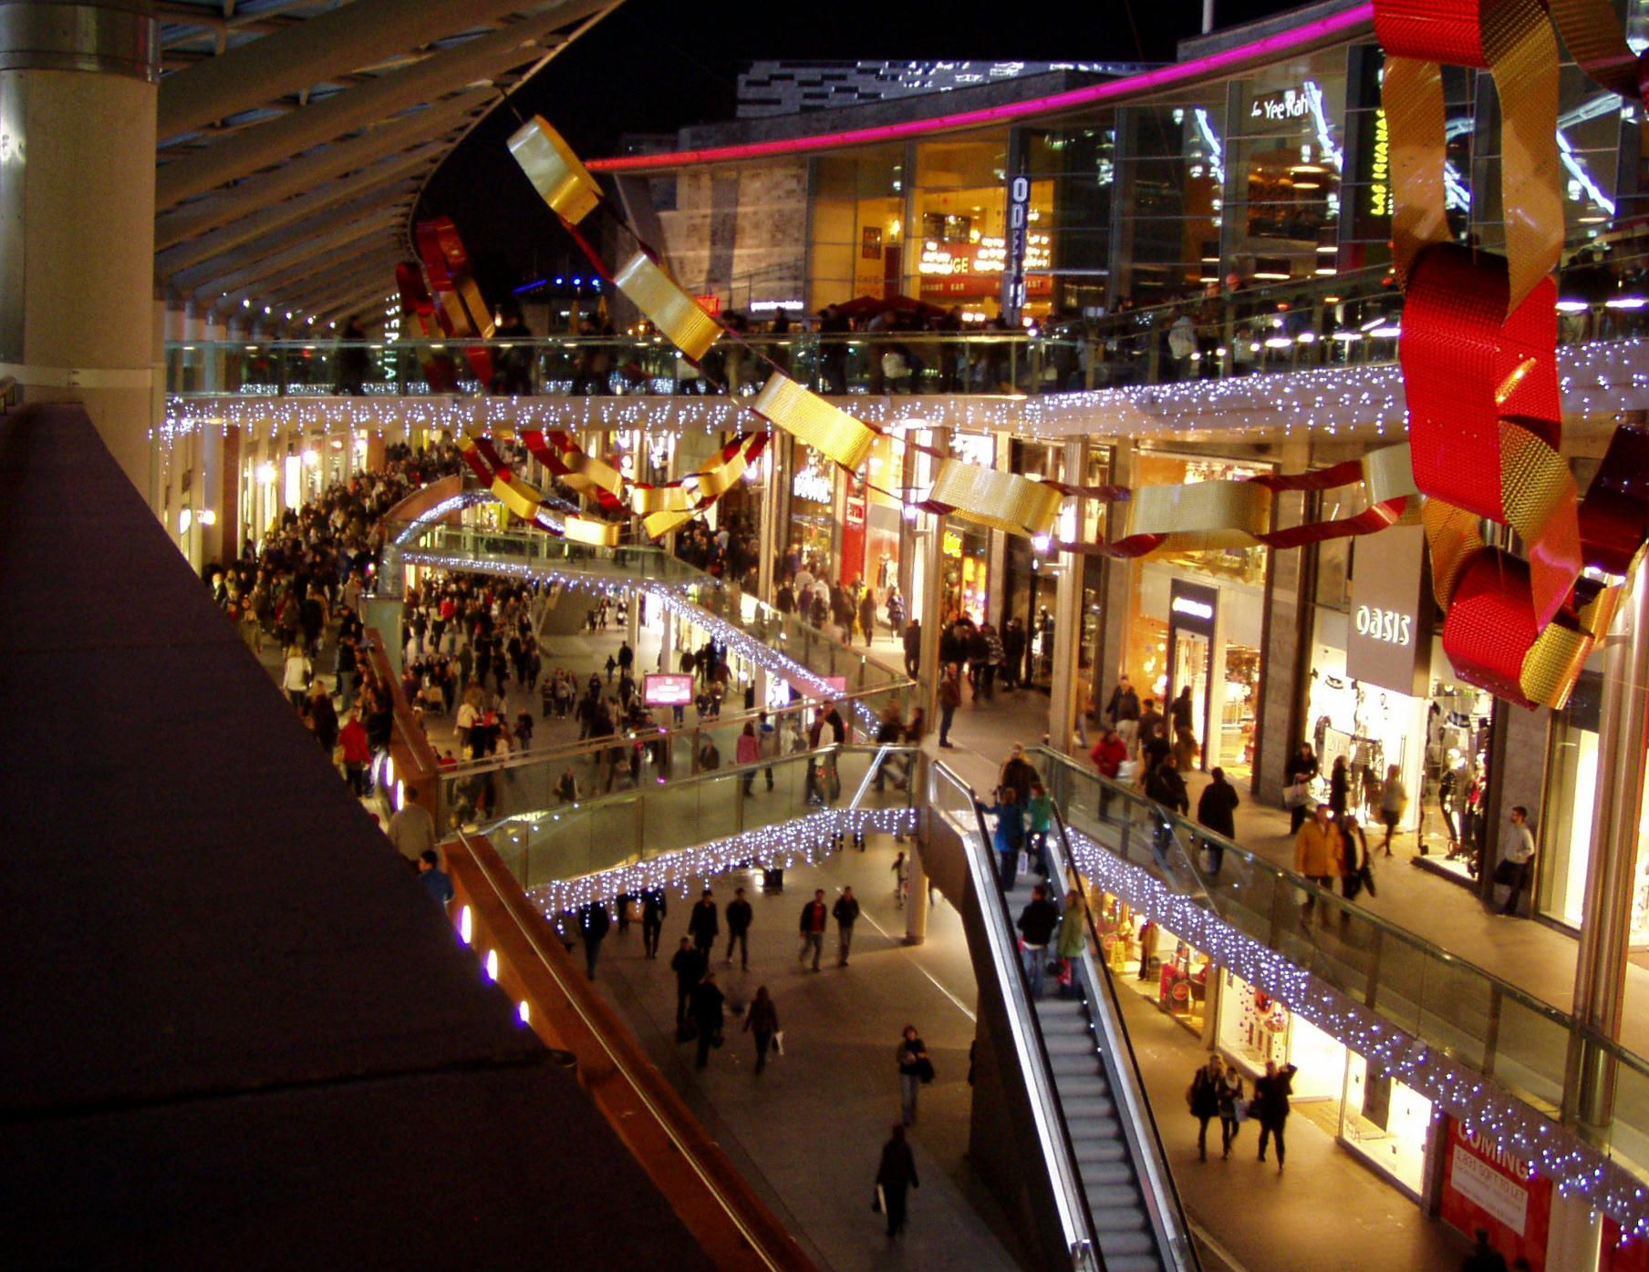

Shopping Mall

Liverpool, UK

Rutvi Shah | Coursera Capstone | October 2020

# Introduction:

Liverpool ONE is the largest open-air shopping center in the UK and the [ninth-largest shopping center overall](https://en.wikipedia.org/wiki/List_of_UK_shopping_centres).

Each store was created by a different architect, leading to stark differences between some buildings, one way in which Liverpool ONE differentiates itself from other shopping centers.

* With around 170 stores and services, Liverpool ONE is the largest shopping center in the city.
* For many local people and especially tourists, visiting shopping malls is great enjoy and relaxing. They can buy almost anything they wish in one place, go to restaurants or go to cinema.
* Opening shopping malls, allows property developers to earn consistent rental income. Opening shopping malls requires serious consideration and takes many factors that makes the whole process more complex.
* Location of shopping mall is one of the most important decisions and can determine how successful the project will be; and we will examine the city clusters to decide where the place for shopping mall will be the best for the process of building

## BUSINESS here:

The goal of this project is to analyze and decide where to build a shopping mall in Liverpool (United Kingdom).

Using Data Science and Machine Learning algorithms, this project try to answer the question is it worth building a new Shopping Mall in Liverpool and especially determine where to build it.

Database:

1. List of neighbors in Liverpool.
2. Latitude and longitude of these neighbors.
3. Venue data, especially the data about shopping malls

Sources and Methods:

We will be using web scraping tools like Python requests and beautifulsoup packages to extract the data from Wikipedia page("https://en.wikipedia.org/wiki/Category:Areas_of_Liverpool") which has 41 neighborhoods. With Python Geocoder we will get longitude and latitude of every neighborhood in the city.

Then we will use Foursquare API, who provide many categories of venue data. This project contains many Data Science skills, from data scrapping, working with Foursquare, data wrangling, data visualization, data cleaning, machine learning & map visualization (Folium).